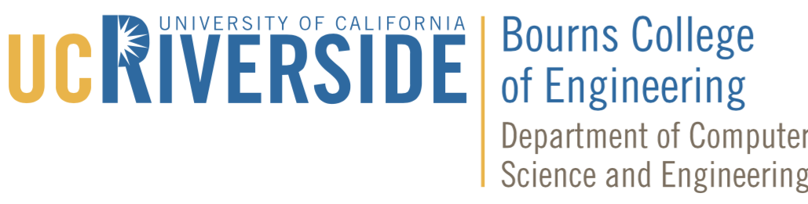

New Graduate Student Orientation
Fall 2019
Monday, September 23, 2019

8:30 – 9:15 am CSE Technical Orientation
Winston Chung Hall, Rooms 129, 132, 133

9:30 – 10:30 am CSE Department Welcome
Prof. Tao Jiang, Graduate Advisor for Admission
Prof. Rajiv Gupta, Graduate Advisor for Current Students
Ali Davanian, Graduate Student Association President
Watkins 1000

11:00 – 12:30 pm Graduate Division Orientation
University Lecture Hall 1000

1:00 – 3:00 pm CSE Department Orientation
Faculty Introductions (1:00–1:30 pm)
- Prof. Ahmed Eldawy
- Prof. Paea LePendu
- Prof. Stefano Lonardi
- Prof. Walid Najjar
Faculty Presentations (1:30–2:00 pm)
- Prof. Amr Magdy
- Prof. Craig Schroeder

Graduate Program Overview (2:00–3:00 pm)
Watkins 1000
* Light lunch will be provided

3:00 – 3:30 pm CSE Technical Orientation Makeups – (only if you missed morning orientation)
Winston Chung Hall, Rooms 132

3:00 – 5:00 pm Graduate Division Reception
Life Sciences Courtyard

